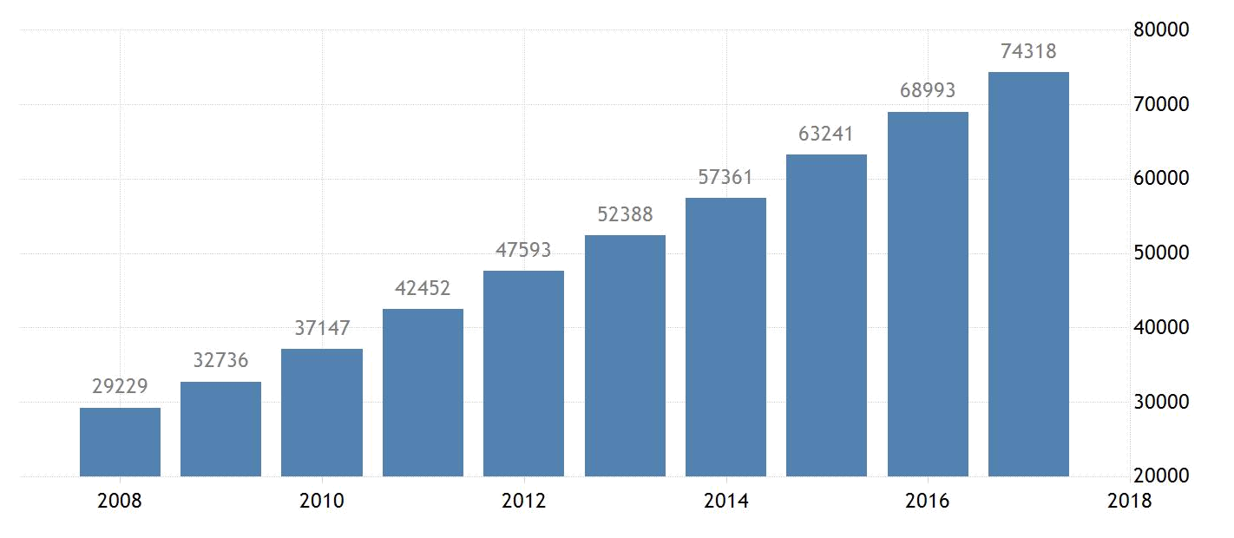

!

Project

Annual Wage Predictor

Presented by:

Sandeep Singh - 013709553

Kalyani Jawanjal - 013767143
1!

Overview

Annual wage predictor will predict approximate wages of people based on various factors. These factors includes a person’s academic background, his/her work experience, location, citizenship status, hours worked per week etc. Whether you are a job seeking candidate, hiring manager, compensation professional or just someone who is curious to know about approximate income of professionals working in different fields, it’s convenient if you get all the required information at one place. It would be helpful for individuals to find out whether they are being paid fairly and what to expect from a certain job by matching it to their profile.

Goals

- To provide a model that serves as a reference to those who want an approximate estimate of who gets what in terms of salary, based on his background and job prospects.
- It will also help others to understand why someone else is drawing more salary and thus they will know which area they can work on to raise their earning potential.
- Be useful to glassdoor, indeed and similar job portals.

Specifications

To accomplish this, regression analysis and linear modeling have been used. Correlating the parameters, we selected independent variables significant to the scope of the project.

Milestones

- Generating modules, identifying independent variables significant to the project and it’s objectives and generating some new insights.

- Providing a reliable and a convenient tool to job seekers and job boards using existing data.
Project Report

Summary

Annual wage predictor has an essential part to play in current times. Increased competition and numerous jobs being posted on different job portals by hundreds of companies for different locations, makes it a tedious affair for individuals to understand what to expect when it comes to salary.

Salary is one factor in job market which is highly erratic and something which does not follow a pattern. While the existing job portals provide salary based on two variables i.e job title and job location, it hits the skid at the point when an individual needs a customized estimate of what it expects as a income for based on qualification, work experience, visa status and other factors which are solely based on an individual's background. Wage predictor would serve the purpose and also help individuals plan their career and educational advancements that they need to make in order to reach a salary estimate that they would like to receive.

The dataset used, has Public Use Microdata sample files which has unclassified documentation about population and housing in USA. Information in these records are collected and maintained by American Community Survey, which is the most relied free source and keeps updated data of population & housing in the States.

Project Goals

- To create a model that would give a customized salary estimate for an individual based on a wide range of factors, pertinent to his background and current situation.

- Assist job seeking individuals to find out salary that they can expect for their background and qualification. This would help them get a clear picture of what is in demand and what skills they should acquire if they are aiming for certain benchmark of income.

- Recognize the aspects that derive salary of a professional.

Key Points

The table below shows training and test set observations of the dataset in divisions of 70% and 30% respectively and thus the total.

Number of observations in total dataset: | 170986
Number of observations in training dataset: | 76850
Number of observations in test dataset: | 32933

Following two models were implemented using R:

1) Linear Regression

2) Lasso Regression

Discovery

Above report was prepared using data of California population in a .csv format, taken from a census website containing 170986 observations (after first round of filteration).

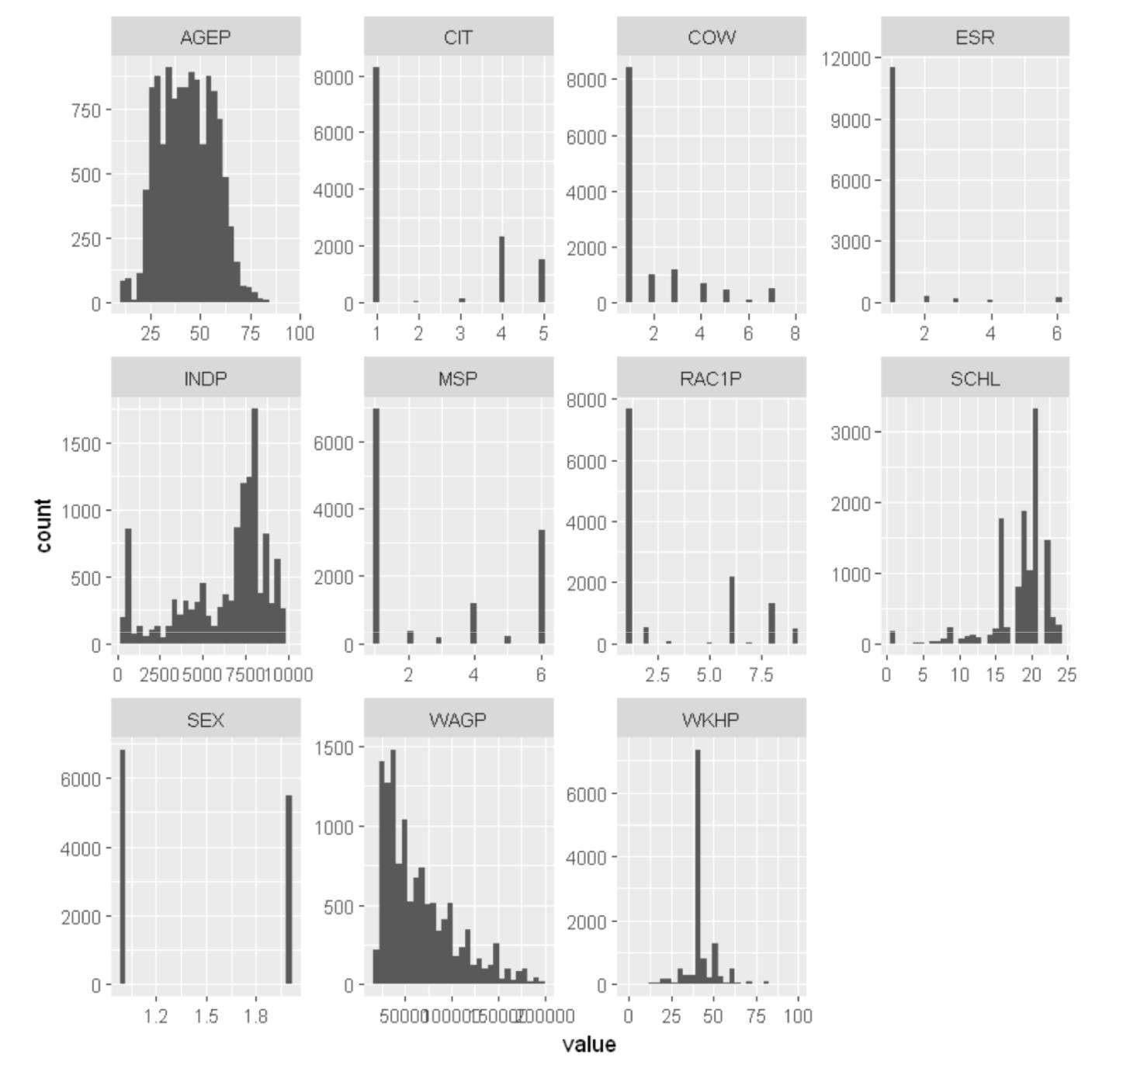

Figure 1.0

In figure 1.0, variables incorporated details like age, industry, gender, academic level etc. While WAGP indicating annual wages was considered as a response variable. Following are the observations based on above plots of each variable:

- AGEP (Age of a Person): This graph shows that majority belongs to the age group ranging between 15-78 years old.
- CIT(Citizenship): It shows that maximum people (observed) in California were born in United States. (Code 1 : Born in US )
- COW(Class of Workers): This shows that private and for-profit organizations have maximum California residents working for them.
- ESR(Employment Status recode): This graph shows that maximum people in California are employed civilians.
- INDP(Industry recode): This shows that California has it’s masses working across distant industries.
- MSP(Marital Status): This shows that majority of people in California are married.
- RAC1P (Race Code): This graph shows that majority of the population in California constitutes White followed by Asians and Islanders.
- SCHL(Schooling level): This shows that majority in California are bachelor’s degree holders followed by those who are high school graduates.
- SEX: Majority of the working population in California are male.
- WAGP (Annual Salary): This is the response variable. Annual salary of California residents.
- WKHP (Number of Hours worked/week): Majority of the people in California work for 40 hours per week.

We used a box plot to recognize outliers. We observed that, about 37% data was missing from different fields in the dataset.

Please refer to figure 2.0 below.
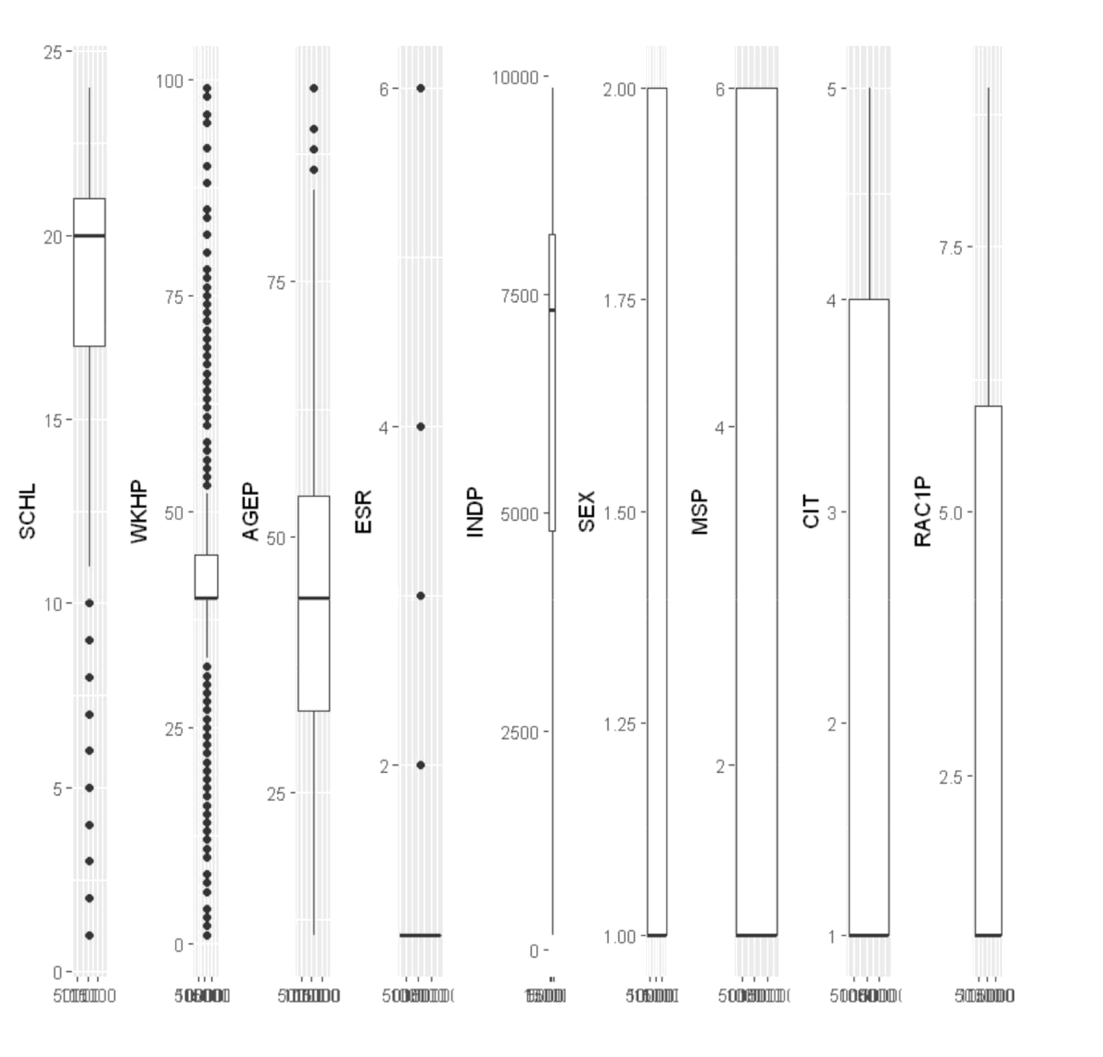

Figure 2.0

Data Preparation

We gathered data from census website. The dataset was originally zipped and was in a comma separated file format. We performed following steps in the phase of data preparation:

- We saved the dataset in a relational database system file.

- Removed correlated predictors.
- Centered and scaled data.
- Executed descriptive stats.
- Rounded of missing values.
- Removed outliers.
- Removed near zero variance variables.
- Transformed the data.
- Divided the dataset in test and training sets.

This process incorporated use of Tableau, SQL,R and Microsoft Excel.

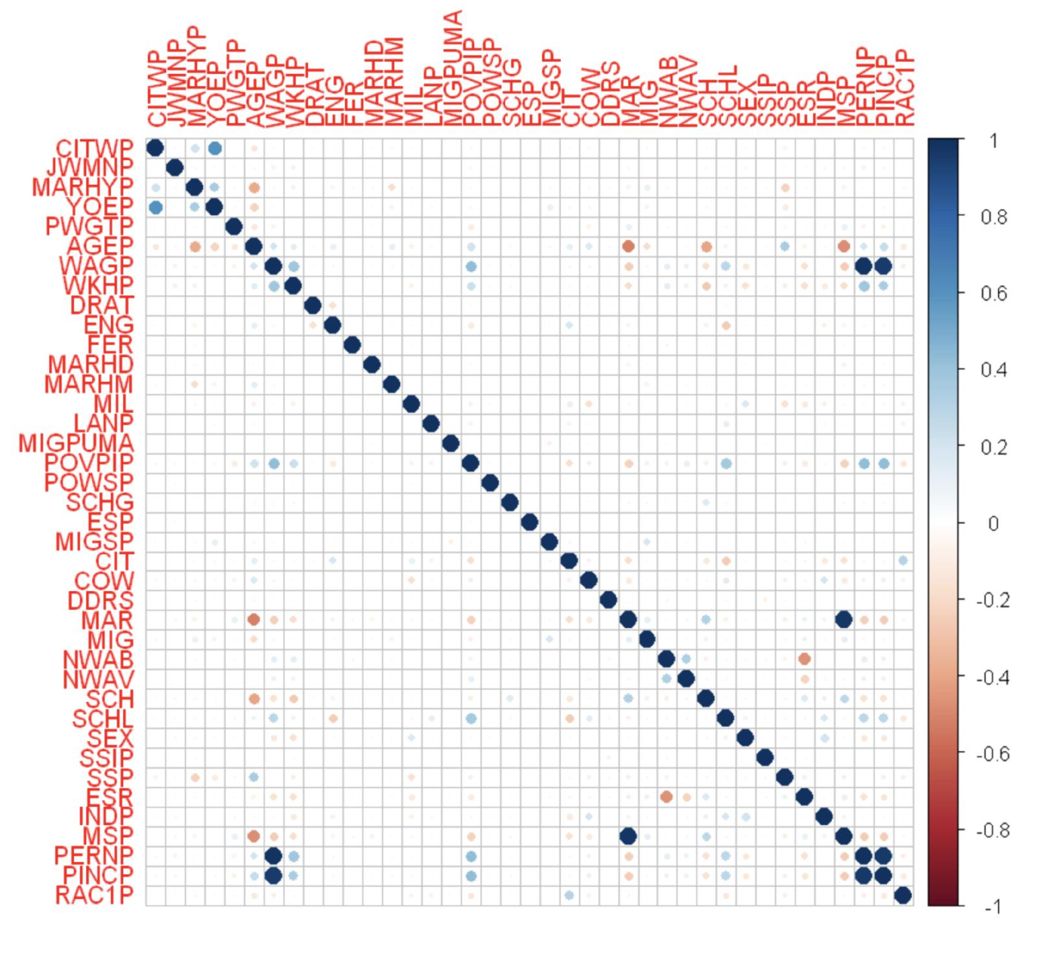

Figure 3.0 Correlation Matrix (showing correlations between different variables)

Model Building

Models were implemented using CARET package and variable importance figure was obtained plotting the significant predictors. Please refer to figure 4.0.

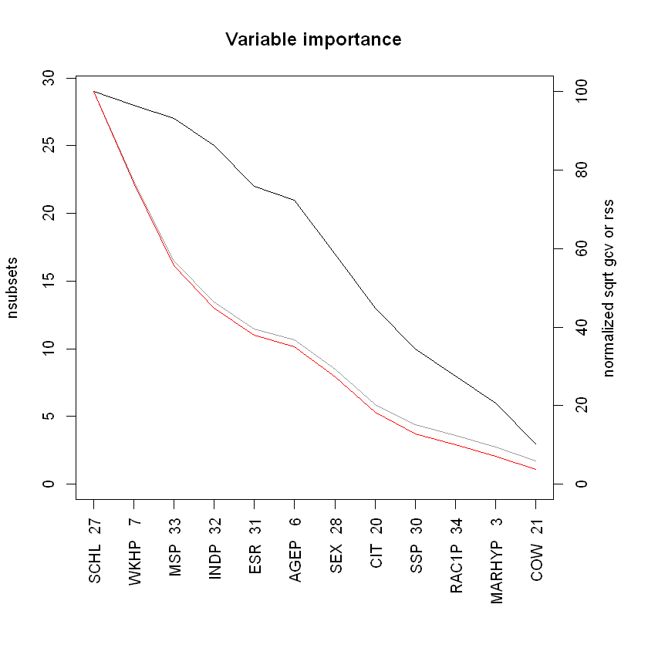

Figure 4.0: Variable Importance
Results

To gauge accuracy of models, we calculated R^2 and Root Mean Square Error values shown in figures 5.0 and 5.1 below:
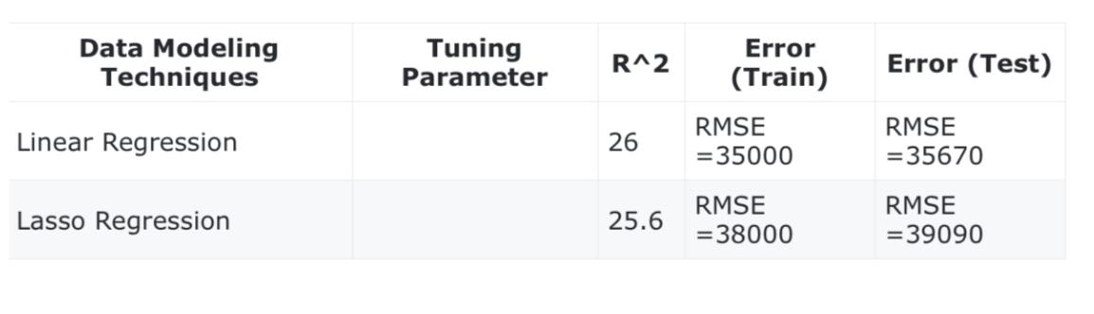

Since the difference between test and train error was large, we re-executed the modes on some of data with residuals were zero. Hence, we obtained a better lower Root Mean Square Error and R^2 and they were as follows:
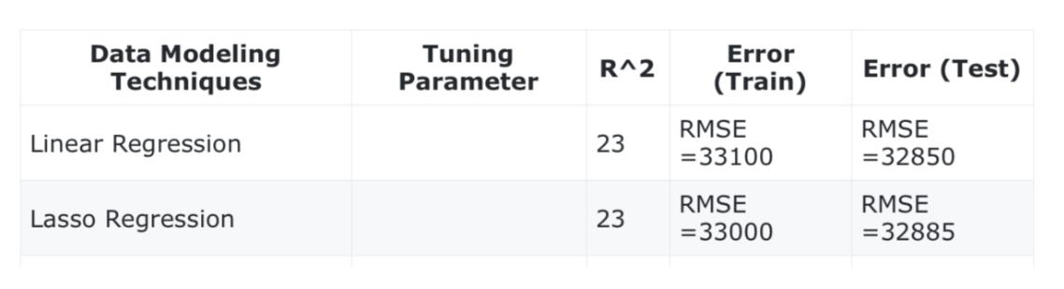

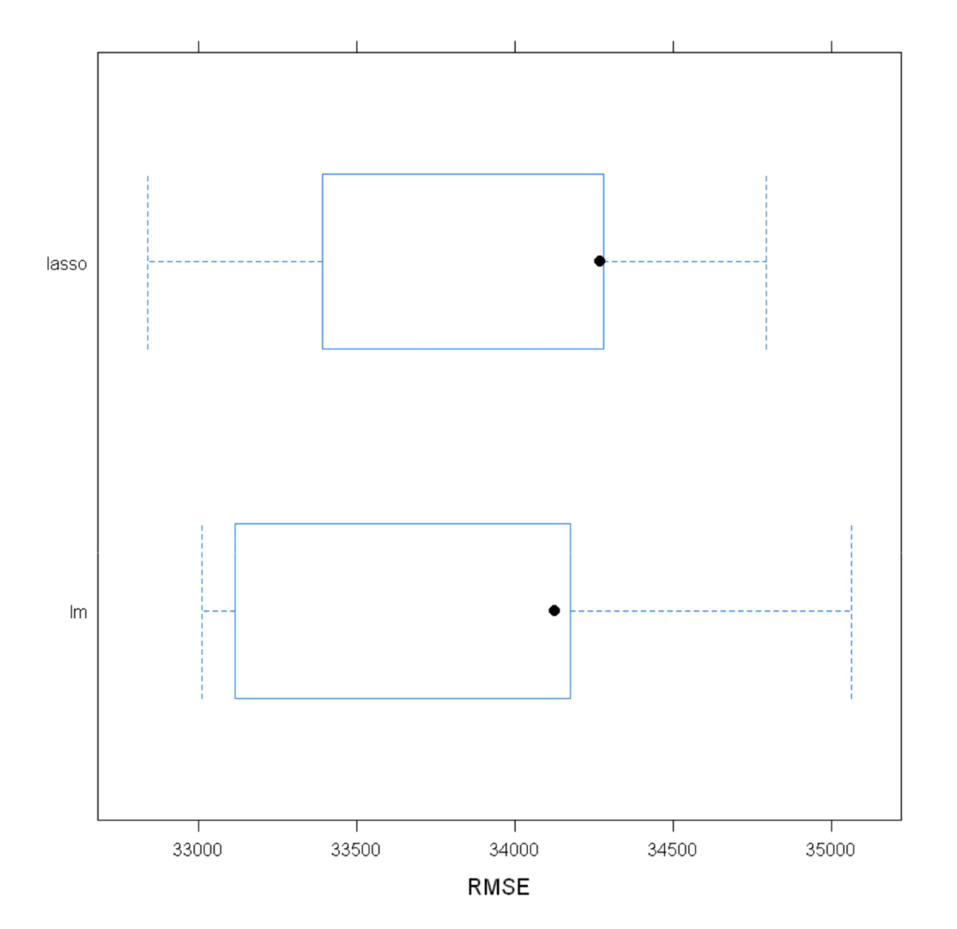

Figure 5.0 : Root Mean Square Error

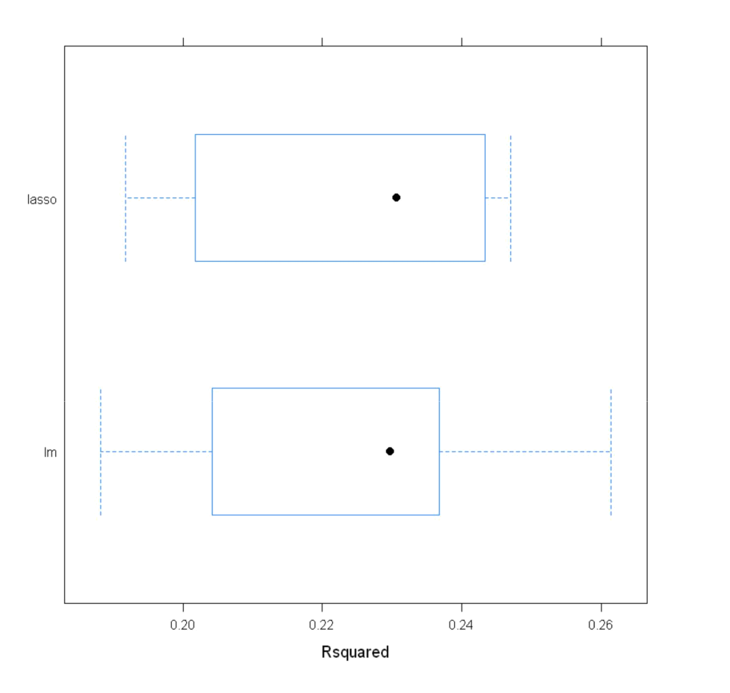

Figure 5.1: R squared
Recommendations

We would suggest running models like bagging tree and rainforest which may improve accuracy and give better R-Squared value which will contribute to the betterment of job portals. Including observations from all other states in USA would also give it an edge over other job portals.

References

1. Caret Official Documentation:

https://cran.r-project.org/web/packages/caret/caret.pdf

2. Ggplot Document:

https://cran.r-project.org/web/packages/ggplot2/ggplot2.pdf

- American Community Survey Data Published by Census Board(2016): https://www.census.gov/programs-surveys/acs/data/pums.html
- Analytics Vidhya blogs:
https://www.analyticsvidhya.com/

